**CG2.2: Software Development**

1. **Tables**

Name: tblBookings

Purpose: Holds all the bookings which can be made

Method of development: Made using design view

Notes: All the seats that can be booked and the seats that are booked are in this table. You can recognise the difference by the ‘IsBooked’ field. If it is true then the seat is booked and if it is false then it isn’t booked. Also if a seat isn’t booked then the ‘CustomerID’, ‘PerformanceID’ and ‘method of payment’ fields are empty as this information is unknown yet and if it is booked then the following information is available. This table is linked to tblCustomer and tblPerformance

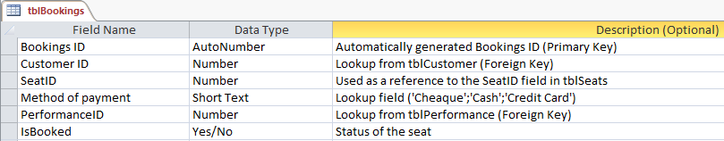

Name: tblCustomer

Purpose: Holds the customer details

Method of development: Made using design view

Notes: This table is linked to tblBookings.

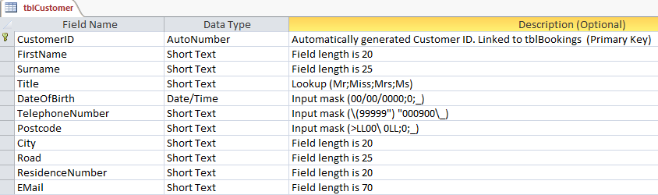

Name: tblPerformance

Purpose: Holds the performnace details

Method of development: Made using design view

Notes: This table is linked to tblBookings.

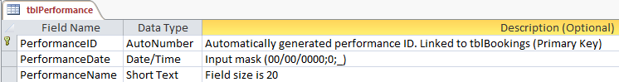

Name: tblsecurity

Purpose: Holds the User’s details

Method of development: Made using design view

Notes: This table is a part of my security system as all the users are stored in this table with their level and unique password

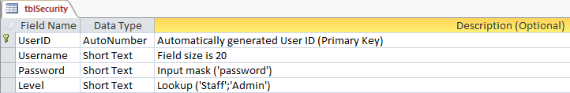

Name: tblSeats

Purpose: Holds the seats information (eg. Price)

Method of development: Made using design view

Notes: This table is used as a reference to use when making a new performance. All the seats are copied to tblBookings with the new performance ID just made. This is done every time a new performance has been created.

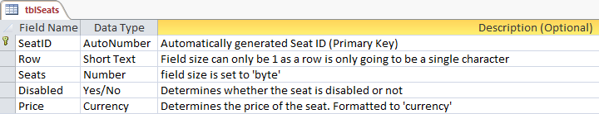

1. **Forms in design view**

Name: frmAddPerformance

Purpose: Allows the user to add extra performances

Method of development: Using blank form

Based On: tblPerformance

Notes: This form allows us to add an extra performances.

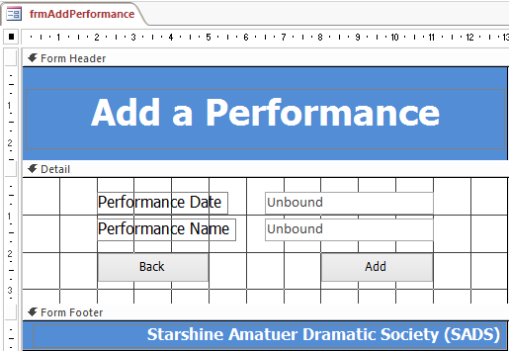

Form title

CmdAdd: Adds a new performance to tblPerformnace and tblBookings with 197 seats using VBA. See section CG2.3 for code.

Name: frmAvailableSeats

Purpose: Allows the user to view all the seat

Method of development: Using blank form

Based On: tblBookings

Notes: This form allows us to view all the seats whether they are booked or not. This will help the user in seeing all the seats in a more visual way rather than going into the table and seeing which seats are booked and which are not which can get very frustrating and time consuming because it’s hard to see whether a seat is booked or not in a table because of all the other information in the same table. Also some times the table has more than 500 records depending on how many performances there are making it even harder to find the seat you are looking for. Moreover, I would not like users accessing the tables directly because of potential security issues.

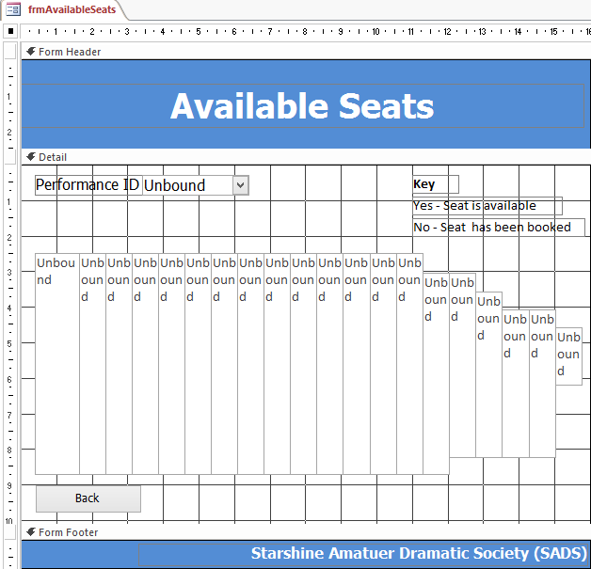

Form Title

Name: frmBookings

Purpose: Allows the user to make a booking

Method of development: Using blank form

Based On: tblBookings, tblPerformance, tblCustomer

Notes: This form allow the user to make a single or a multiple booking. The design of this form is exactly the same as the design’s in my previous forms and will continue to stay the same. There is no data entry required on this form, all the user is doing is selecting information from list boxes or combo boxes. After the booking had been made a receipt is opened.

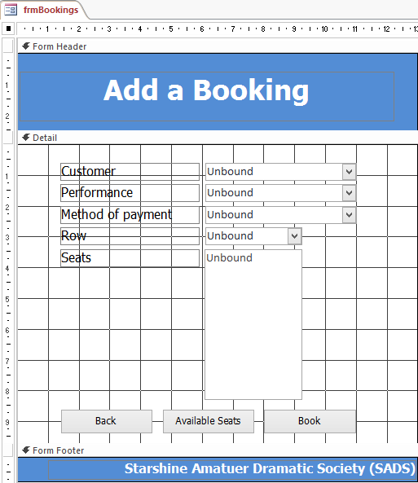

Form Title

CmdBook: Calculates total booking price and make a booking(s) using VBA. See section CG2.3 for code.

Name: frmCustomer

Purpose: Allows the user to add, delete and edit a customer

Method of development: Using blank form

Based On: tblCustomer

Notes: As you can see my house-style is the same again as before to keep my work consistent. Also you can do a lot of things with this form such as adding, deleting or updating a customer all in one form. All the buttons are clearly laid out and it is simple to use.

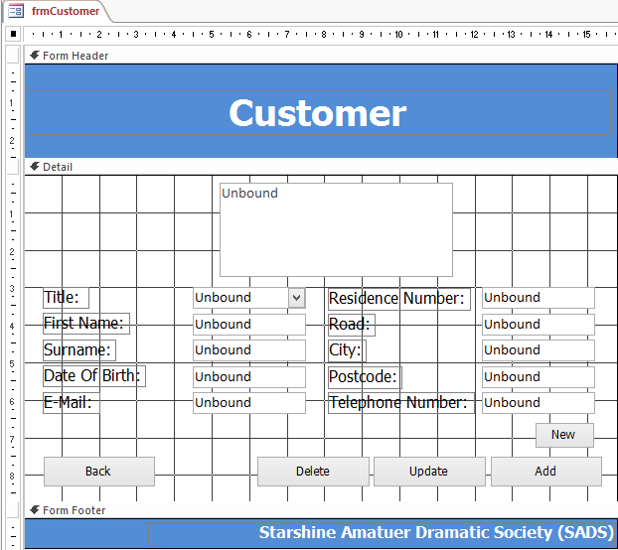

CmdAdd: Adds a new customer using VBA. See section CG2.3 for code

CmdUpdate: Updates selected customer details from listbox using VBA. See section CG2.3 for code

CmdDelete: Deletes selected customer from listbox using VBA. See section CG2.3 for code

Name: frmLogin

Purpose: Secures the system of any unauthorised access and determines whther the user is and admin or a standard user

Method of development: Using blank form

Based On: tblSecurity

Notes: If the username and password are wrong then the system will not allow the user into the system

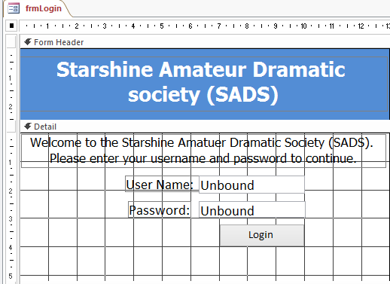

CmdLogin: Checks to see if the netered values are in tblSecurity and if not tells user to type in the correct details using VBA. See section CG2.3 for code

Name: frmMainMenu

Purpose: Allows the user to easily navigate between forms

Method of development: Using blank form

Based On: N/A

Notes: If the user is and admin then the ‘User’ button and ‘Add performance’ button will be enabled. Otherwise, if the user is a standard user then the ‘User’ button and ‘Add performance’ button will be disabled for security reasons.

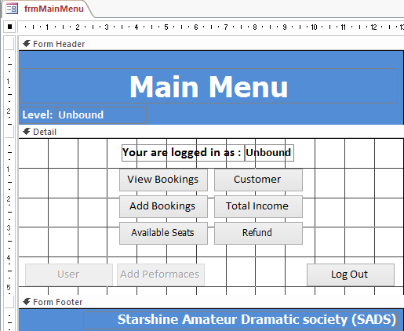

Text boxes: shows the user what their name and level is

Button are disabled if the user is a standard user level

Name: frmRefund

Purpose: Allows the user to refund a booking(s)

Method of development: Using blank form

Based On: tblBookings

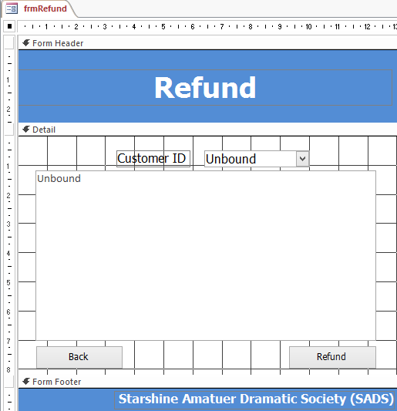

cmdRefund: Unbooks the selected seats in the listbox using VBA. See section CG2.3 for code

Name: frmUser

Purpose: Allows an admin user to add, edit or delete users

Method of development: Using blank form

Based On: tblSecurity

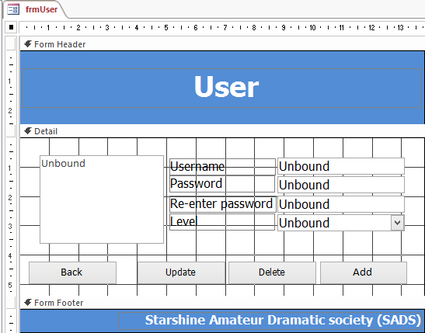

CmdAdd: Adds a new User using VBA. See section CG2.3 for code

CmdDelete: Deletes selected User from listbox using VBA. See section CG2.3 for code

CmdUpdate: Updates selected User details from listbox using VBA. See section CG2.3 for code

Name: frmViewBookings

Purpose: Allows a user to view all bookings made by a selected customer

Method of development: Using blank form

Based On: tblBookings

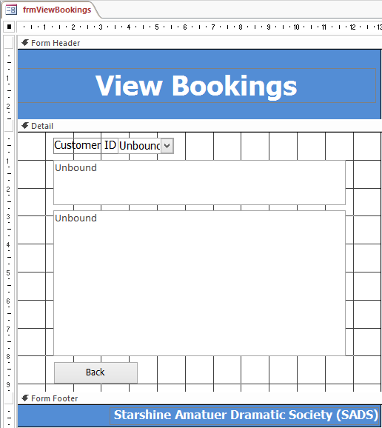

**2a. Forms in form view**

Name: frmAddPerformance

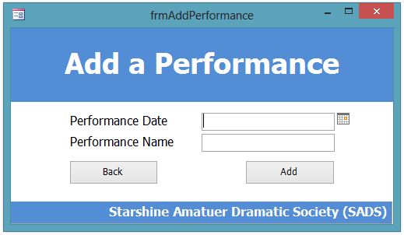

Name: frmUser

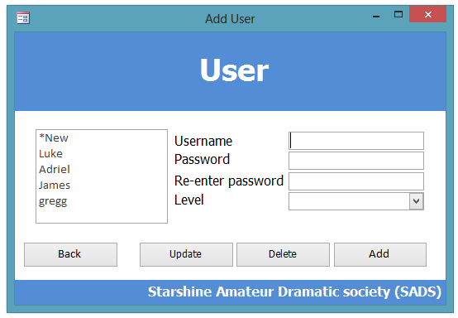

Name: frmViewBookings

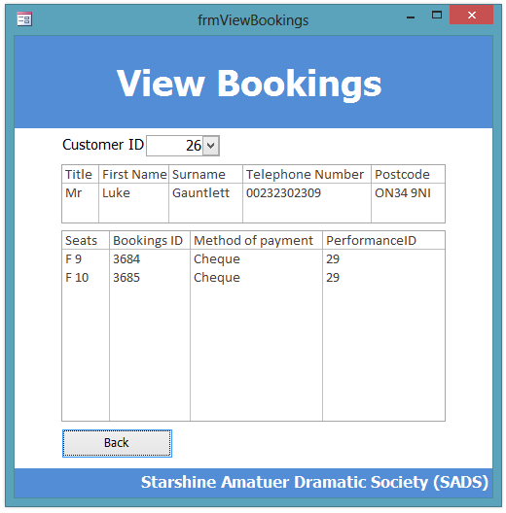

Name: frmLogin

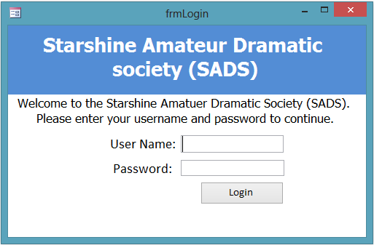

Name: frmAvailableSeats



Name: frmBookings

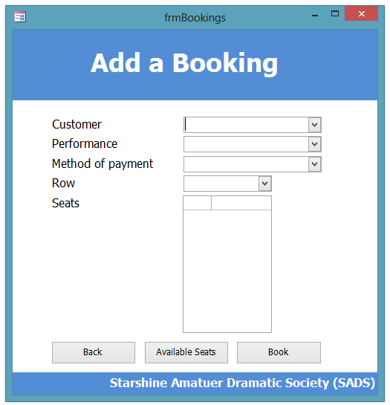

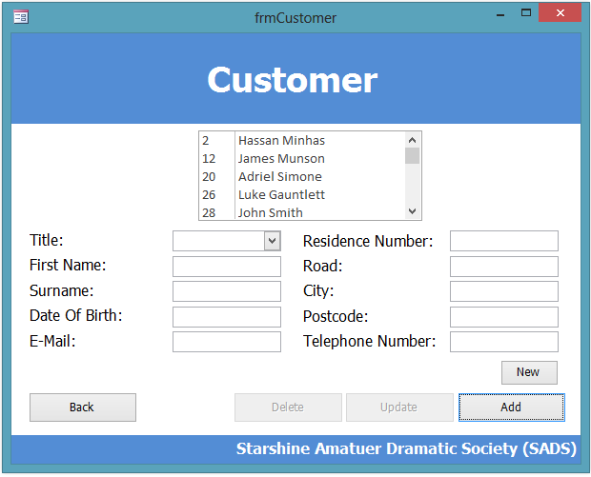Name: frmCustomer

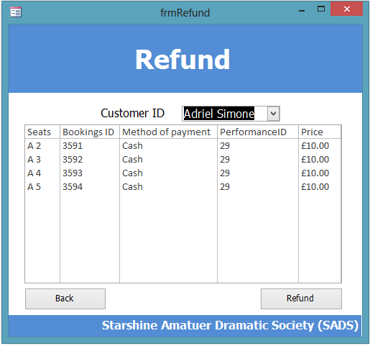Name: frmRefund

Name: frmMainMenu

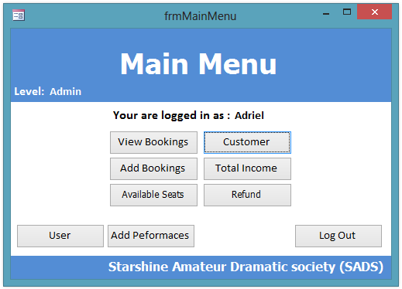

Name: qryReciept

Purpose: This is the query that rptReciept takes information from

Method of development: Design View

Based On: tblBookings, tblSeats, tblPerformance

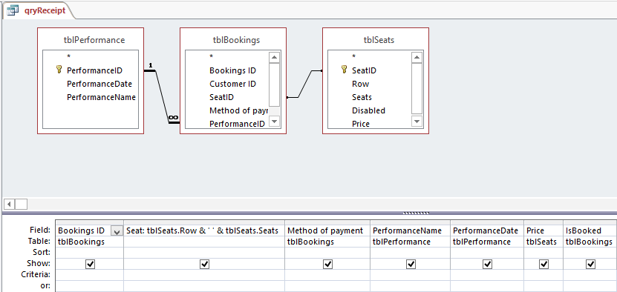

tblSeats

tblBookings

tblPerformance

Name: qryTotalIncome

Purpose: This is the query that rptTotalInome takes information from.

Method of development: Design View

Based On: tblBookings, tblSeats, tblPerformance

Notes: This query stores all the bookings and groups them by the performance ID and then adds up the price’s to give total price of each performance

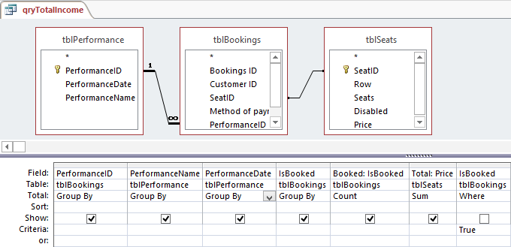

Only booked records are shown

Name: rptReciept

Purpose: Acts as a form of booking conformation

Method of development: Using blank report

Based On: qryReciept

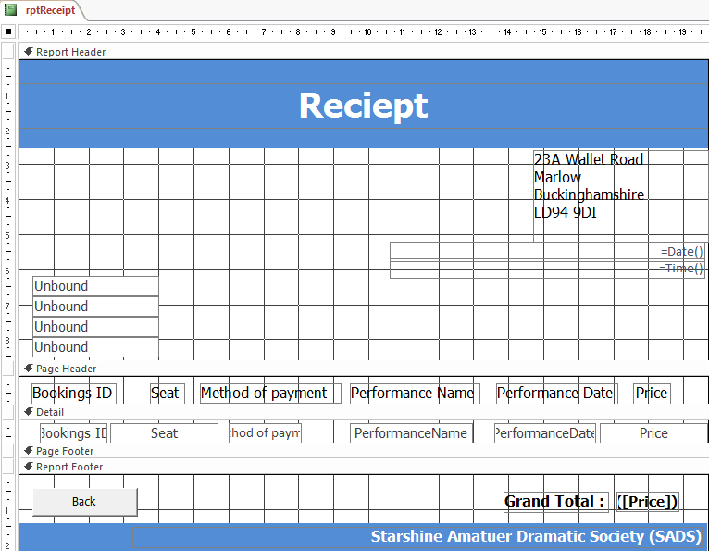

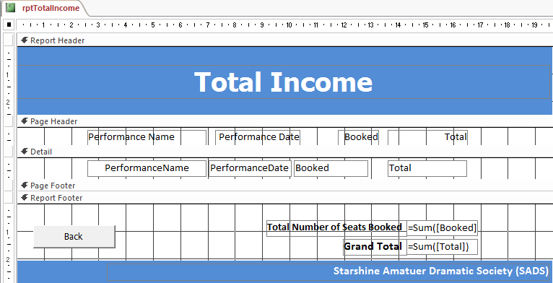Name: rptTotalIncome Purpose: Shows that total income from ticket sales Method of development: Using report wizard Based On: qryTotalIncome